React Router (V6)

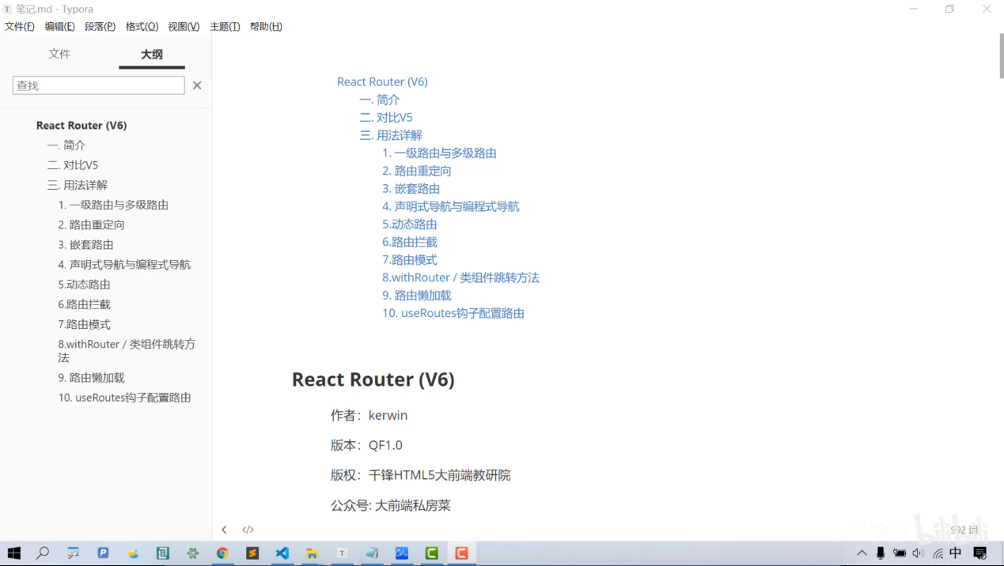

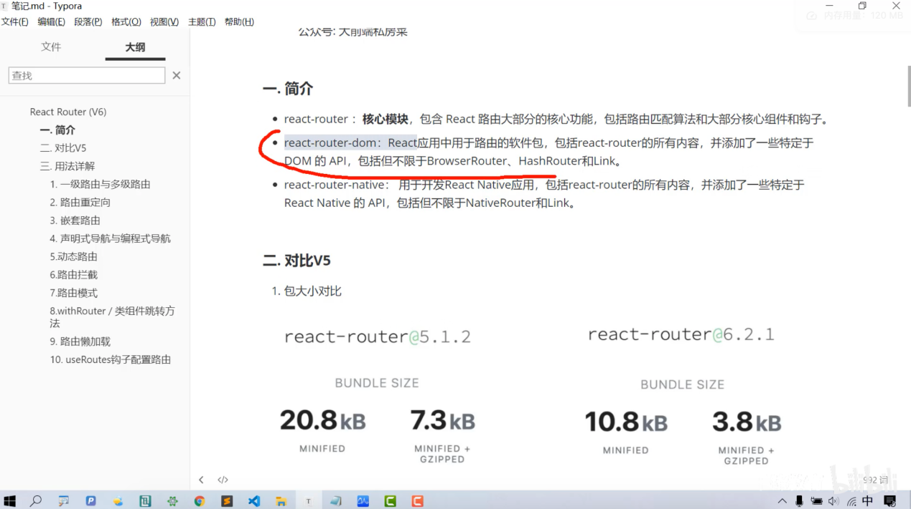

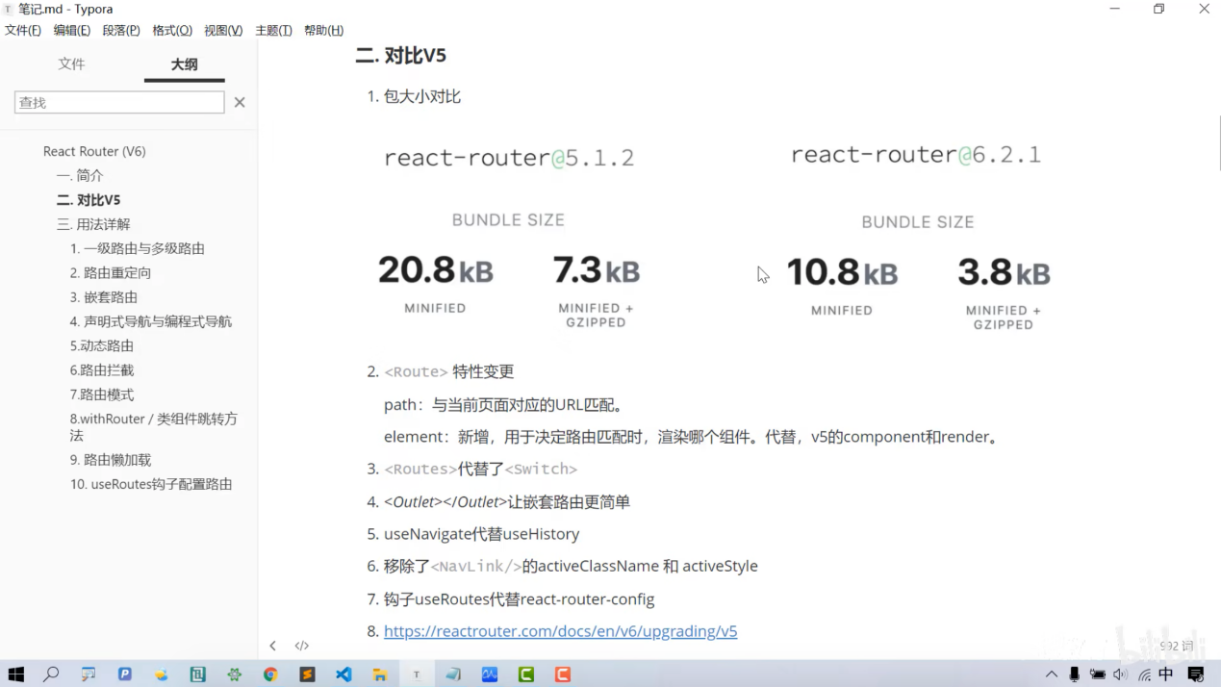

create-react-app myapp2

npm i [react-router-dom@6.2.2](mailto:react-router-dom@6.2.2)

